Assignment 1

COMP 3411

Ryan Woodward - T00671761

2020

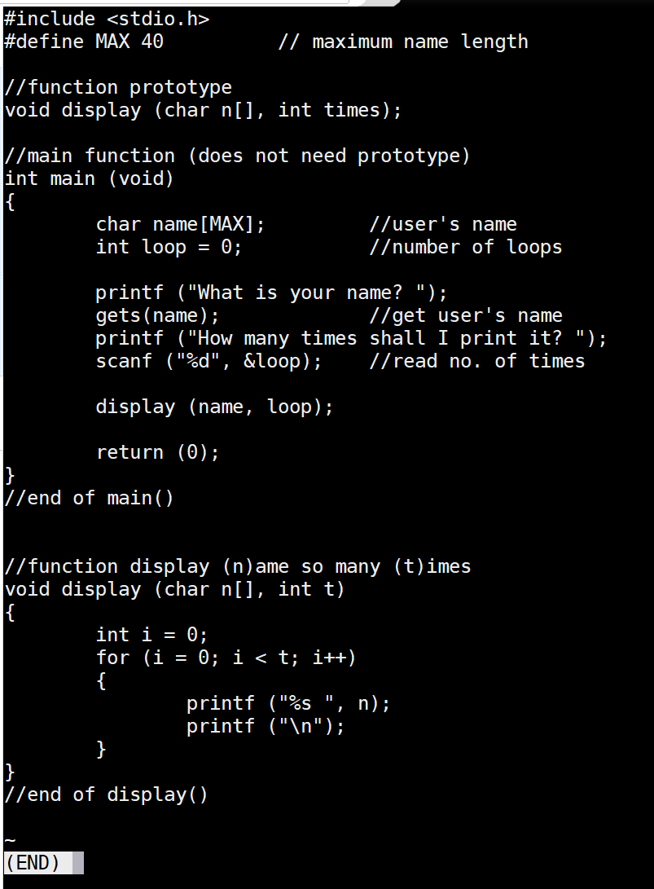

Figure : Screenshot of smallprogram.c

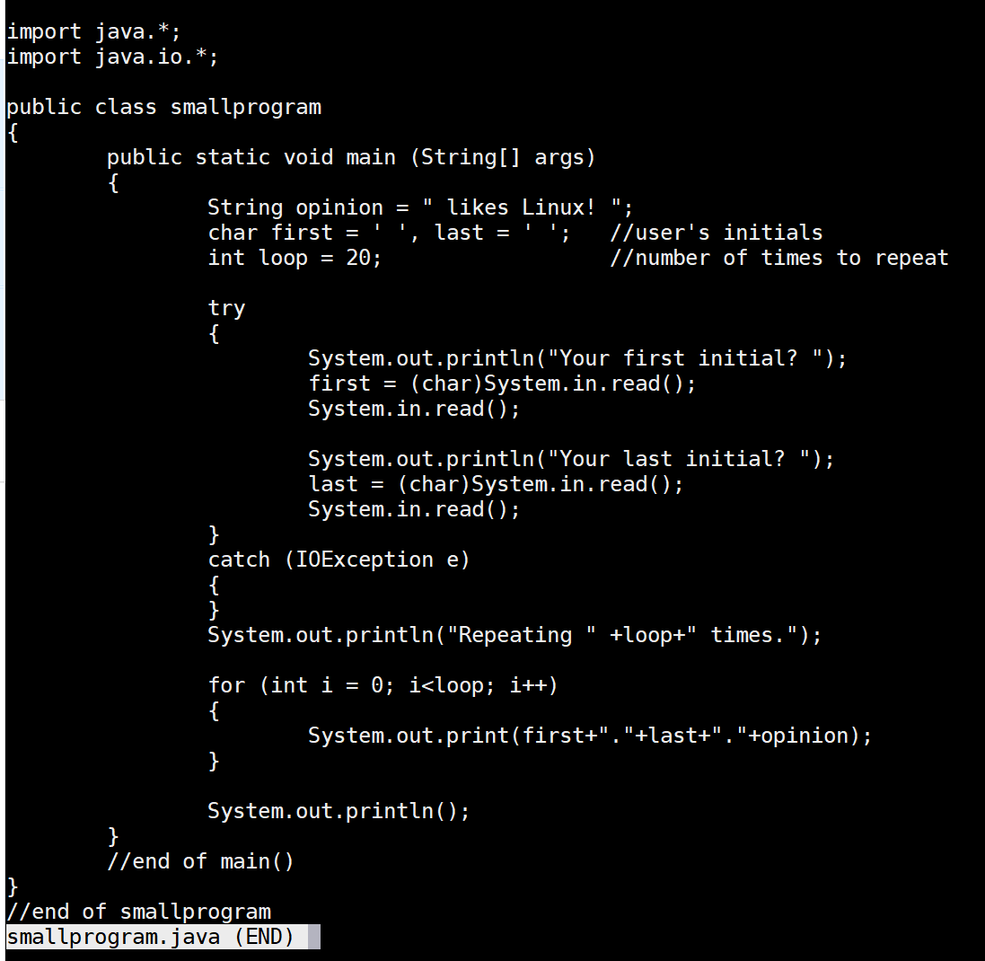

Figure : Screenshot of smallprogram.java

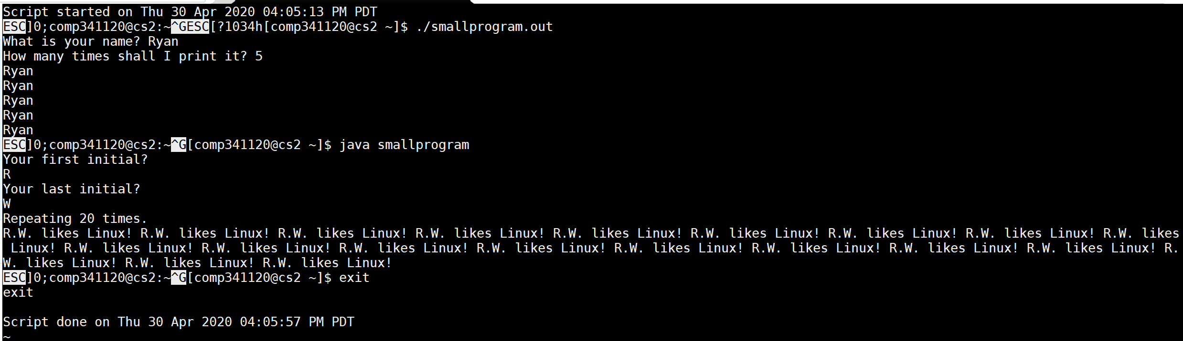

Figure : Screenshot of a1capture.txt